
QUALITY ALERT

Customer: Solar Date: Nov 25, 2020
Die: 15001 Type of Complaint: Solar REJECT

Description: Solar Reject due twisting causing issues when welding together. Glazing bead pocket and tower does not line up.
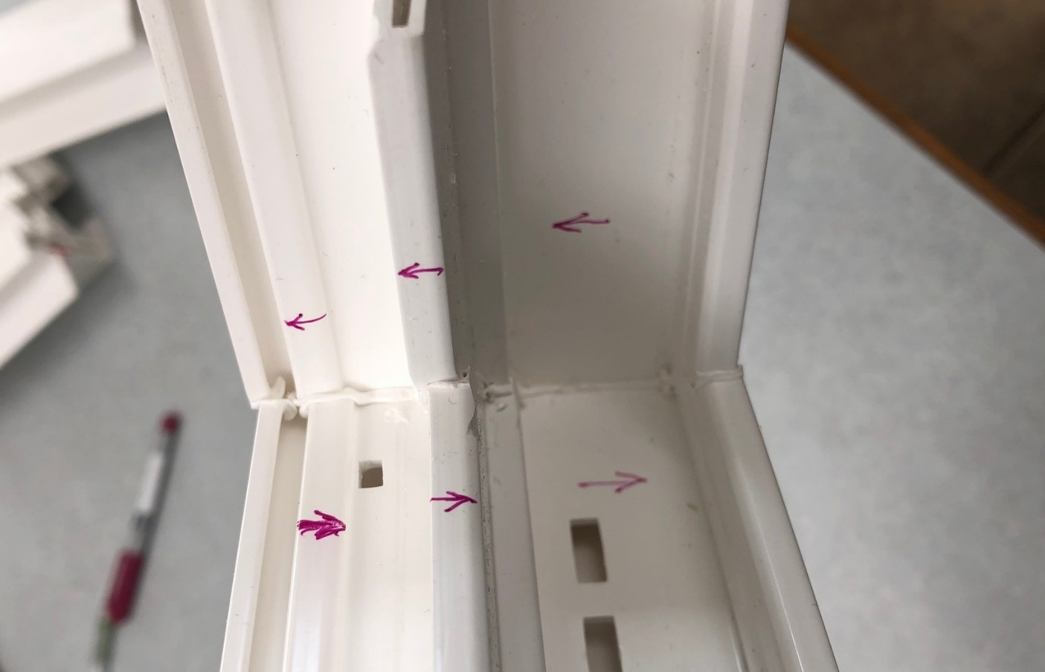
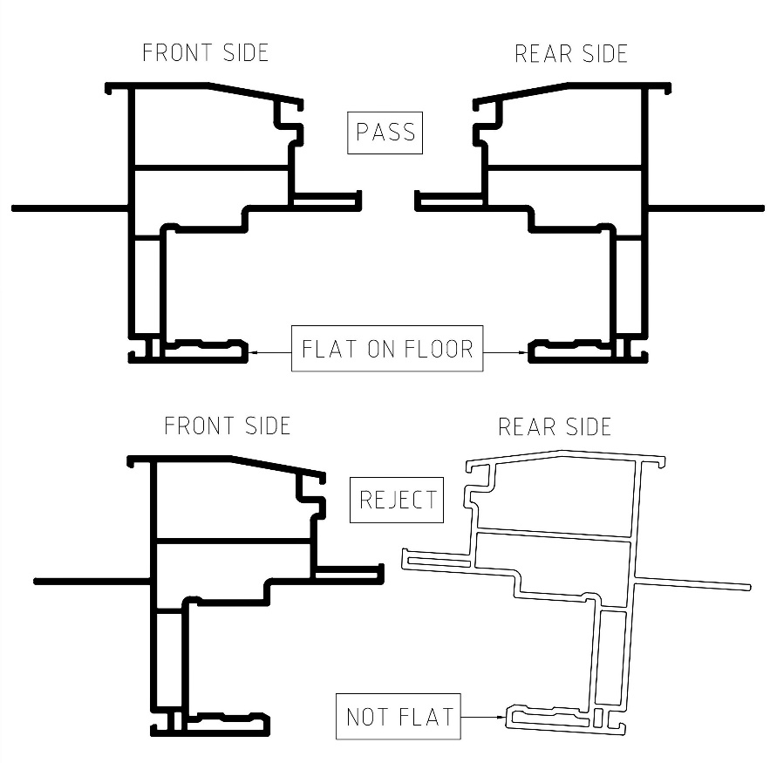

BY SIGNING BELOW, YOU ACKNOWLEDGE THE PROBLEM ABOVE AND AGREE TO MONITOR THIS ISSUE IN FUTURE PRODUCTION RUNS.
DAY SHIFT |  | AFTERNOON SHIFT |  | NIGHT SHIFT
NAME | SIGNATURE | NAME | SIGNATURE | NAME | SIGNATURE

